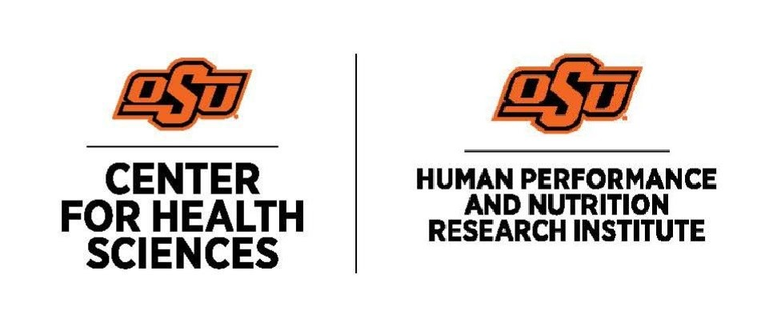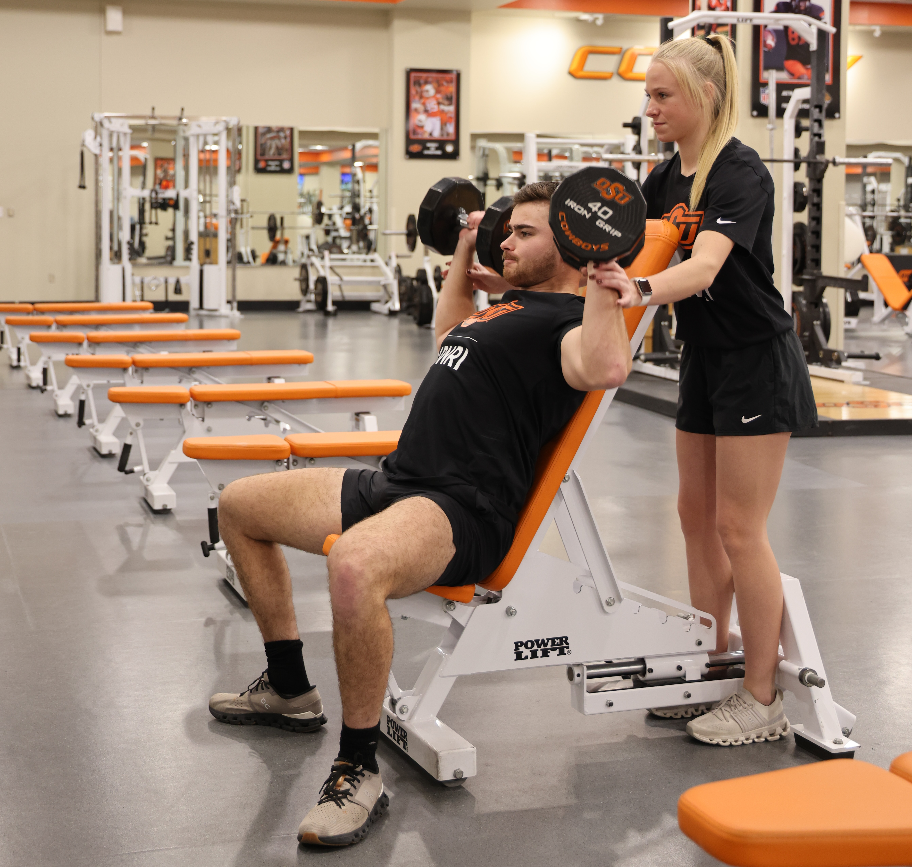  Injury Prevention Programs: Revisiting the FIFA 11+  Learning Objectives  -Review components of the FIFA 11+.  -Summarize FIFA 11+ as an evidence-supported injury prevention program.  -Describe resources available for implementation.  Schedule and Format  - Wednesday, February 4, 2026; 12-1:00pm  Cancellation/Refund Policy  - None. No payments necessary.  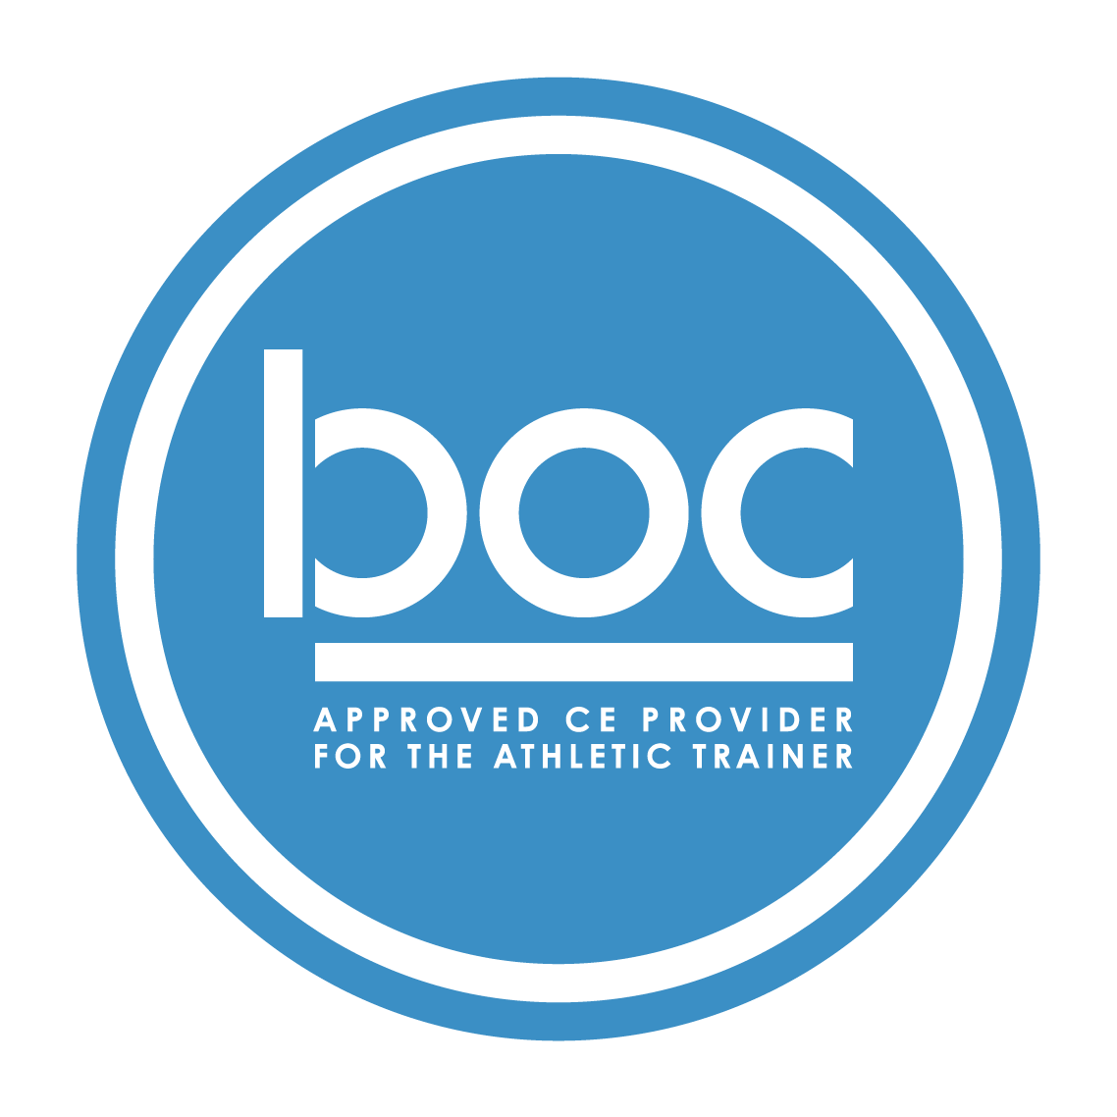  Oklahoma State University Center for Health Sciences Office of Continuing Medical Education (BOC AP#: P12117) is approved by the Board of Certification, Inc. to provide continuing education to Athletic Trainers (ATs). This program is eligible for a maximum of (1.00) Category A hours/CEUs. ATs should claim only those hours actually spent in the educational program.
  Lance Walker, MS, PT, CSCS, USAW
  ____
  NO REQUIRED MATERIALS OR EQUIPMENT
  ____
  1-HOUR CATEGORY A CEU AVAILABLE
  ____
  TSET Grant
  NO FEES
  ____
  SESSIONS ARE VIRTUAL VIA ZOOM
  OSU CENTER FOR HEALTH SCIENCES
  1111 W 17th St
  Tulsa, OK 74107
  918-561-8255
  Register:
  https://redcap.okstate.edu/surveys/?s=3KY39MLMMHKCCHMY
  Website
  https://medicine.okstate.edu/echo/atsm-echo.html

